CIRENCESTER ECLECTIC STRINGS
We are an enthusiastic group of local string players (violin, viola, cello and double bass) who enjoy playing together. We draw members from all over Gloucestershire, Wiltshire and beyond.
Under the exciting direction of our conductor Nick Steel we recently enjoyed a sell-out concert in the Corinium Museum in Cirencester. We play a wide variety of string music from Baroque to contemporary. In addition to experienced players, led by Tina Gardiner, we welcome players of all ages who may be relatively new to playing, or recently rediscovering music. We also aim to develop a love of string ensemble playing in our members.
There is no audition required. Being a friendly, sociable group, we enjoy our supper concerts, a summer celebration and chatting over tea and coffee during the break in rehearsals. We rehearse every Wednesday evening from 8pm to 9.45pm at Watermoor Church Hall, Cirencester.

If you are interested, please email:
contact@eclecticstrings.org
or visit our website:
www.eclecticstrings.org

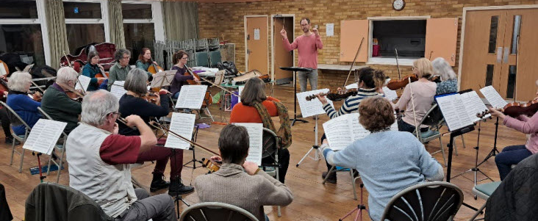

PROGRAMME

Palladio Karl Jenkins

Folk Tune Air and Fiddler’s Fury Alexander Safford

Waltz and Jig (Concordia Suite) Adrienne Spilsbury

Ashokan Farewell Jay Ungar

Serenade for Strings Op 20 Edward Elgar
1. Allegro piacevole 2. Larghetto 3. Allegretto

Libertango Astor Piazzola

Death of Falstaff and Touch her soft lips and part
from the film score to ‘Henry V’ William Walton

Concerto for four violins Op 3 Antonio Vivaldi
Jill Wightman, Liz Fleming, Jo Felstead, Stephanie Robbins
Continuo: Heather Milnes
1. Andante 2. Allegro 3. Allegro

The Entertainer Scott Joplin

--------------------------------------------------------------------
Refreshments (tea, coffee, cake)
will be available in the lobby after the concert



CIRENCESTER ECLECTIC STRINGS

Conductor: Nick Steel
Leader: Tina Gardiner

Violin 1 Tina Gardiner (*)
Kathryn Broadhurst
Stephanie Robbins
Liz Fleming
Heather Milnes
Douglas Butler

Violin 2 Jill Wightman (*)
Jo Felstead
Elizabeth Macdougall
Michelle Sharma
Anna Greenwood
Carrie Winter

Viola Dave Richardson (*)
Rees Jenkin
Sue Mattick
Raman Sharma Bridget Tiffin

Cello Liz Smith (*)
Alan Bingle
Sue Lacey
Cathy Oliver

Bass Matt Kirby (*)
Emily Broadhurst

(*) Section leader

AUTUMN
SHOWCASE

Cirencester Eclectic Strings
Ashcroft Methodist Church
Cirencester
3pm Sunday 19th October 2025
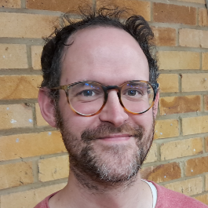

Nick Steel

Tina Gardiner
------------------
NEXT
ECLECTIC STRINGS
CONCERT
6pm Sunday
12th April 2026
CORINIUM MUSEUM

